**Scientific Report**

**Traffic Jam Solution**



By:

Sarah (Chenyuxin)

Tori Ananda Sathio

T. I. Ritzchie Gayatri

William Seto

N.K.Bulan Widhidarma

Jien Martio Harnant

Ralf Pratama Manalu

Pendamping : **Hery Suyanto**

China Indonesia School

Denpasar 2018

1. **INTRODUCTION**
   1. **Background**

In this era, traffic jam has been a daily problem that we must face every day. For solving this problem, government has taken many solutions to improve traffic condition like 3 in 1, progressive tax implementation, increase in vehicle tax and the new policy ‘Odd-Even’. Instead of improving traffic conditions, in fact, they have disrupted the economic and social sectors. These results have made people disappointed.

By just using man power and policies, traffic jam seems have no improvement. So, this time we are going to try something new that can effectively resolve traffic jam. In this case, Arduino will we use to resolve this problem.

Arduino is an open-source platform used for building electronics projects. Arduino consists of both a physical programmable circuit board (often referred to as a microcontroller) and a piece of software, or IDE (Integrated Development Environment) that runs on your computer, used to write and upload computer code to the physical board.

* 1. **Problems**

How to use Arduino?

How to solve the traffic jam by using Arduino?

* 1. **Aim**

Traffic congestion will cause really many negative effects like causing:

• Air pollution (contributes to lung cancer, asthma, and other respiratory diseases, and it has been associated with heart disease and stroke).

• Economic impact (drivers who encounter unexpected traffic may be late for work or other appointments, causing a loss in productivity for businesses and in the drivers' personal lives).

• Road rage (drivers who become impatient may be more likely to drive aggressively or dangerously and it will be dangerous to the surrounding including the driver itself).

• Emergency vehicles (emergency vehicles are unable to respond in an appropriate amount of time because of traffic congestion it can be a danger to you and your property).

So, our aim is to resolve traffic congestion and minimize the effects that caused by traffic congestion.

1. **TEORY**
   1. **Laser and Detector**

Laser is a device that generates and intense beam of coherent monochromatic light by stimulated emission of photons from excited atoms or molecules.

Detector is a device that is designed to detect the presence of an object or substance and to emit a signal in response.

* 1. **Arduino and Microcontroller**

Microcontroller is a small computer on a single integrated circuit and Arduino is a set of development boards that come with pre-tested hardware and software libraries.

In this project, we will use Arduino as our main circuit. Compared to microcontroller, Arduino’s programming language is easier and has a lot of peripheral support (including 3rd parties).

* 1. **Arduino’s Operation**

All programming and peripheral connectivity is done in ATmega328(or similar). The rest of the components support that chip.

The AT mega contains a CPU, RAM, Flash ROM, EEROM, timers, I/O, including an A/D converter etc.

And the things outside of AT mega are a voltage converter, a system clock crystal and a USB interface.

1. **METHOD**
   1. **Materials and Tools**

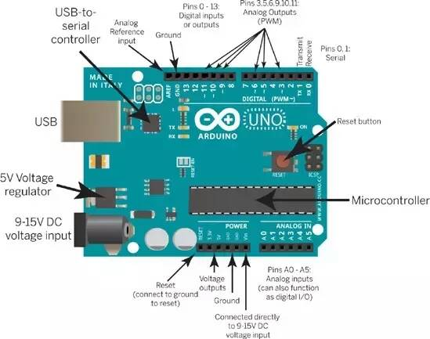 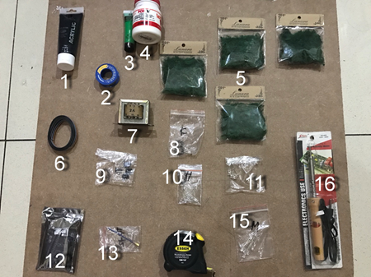

1. Green paint

2.Copper cable

3. Black paint

4. Glue

5. Grass (decoration)

6. Wires

7. Trafo

8. LED (yellow)

9. Detector

10. LED (green)

11. Censors

12.Arduino Uno

13. Laser

14. Ruler

15. LED (red)

16. Solder

* 1. **Circuit**

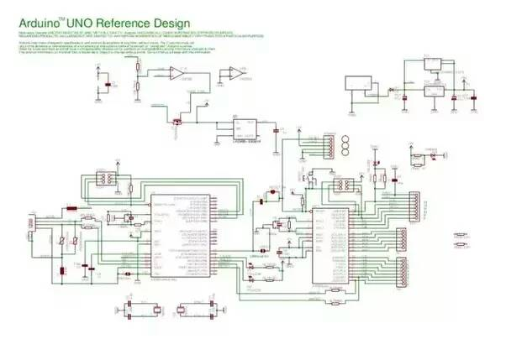

1. **RESULTS**

**The operation of this project**

We plant a laser in the side of the roads to emit a light and send it to our detector. Then, our detector will send the data to Arduino and input it to change the duration of the trafic light. The green light will increase 10 seconds and the red light will increase 10 seconds.

1. **SUMMARY**
2. How to use Arduino?

First, open the Arduino IDE and create a new sketch.Click on the Open tab and find examples. Find the blink sketch and open it. Upload it to your board.

If you'd like, you can add an external LED to the board, by inserting the positive lead of the LED into digital pin 13 and inserting the negative lead into the ground pin.Once you have uploaded the program, the orange LED will start blinking. If you inserted the extra LED, it will start blinking too.

Read the code notes until you understand what each command does. Once you have done that, try making small modifications to the code until you can use these commands and have them committed to memory.

1. How to solve the traffic jam by using Arduino?

We have known that by using arduino, we can control the duration of traffic light. So after detected the traffic condition by using censor, the traffic light will control itself's duration (base on the programme). By using this programme, the road that is more jammed will have longer time to be green.

1. **REFERENCES**
2. https://en.m.wikipedia.org/wiki/Arduino
3. https://www.tutorialspoint.com/index.htm
4. http://zonaelektro.net/resistor-karakteristik-nilai-dan-fungsinya/
5. https://www.youtube.com/watch?v=WUPyBB_s_xQ
6. https://www.youtube.com/watch?v=e1FVSpkw6q4
7. https://www.youtube.com/watch?v=KX_-MPOJNXY
8. https://www.quora.com/How-does-the-arduino-work-What-does-each-component-do-How-does-it-all-come-together
9. https://www.tutorialspoint.com/index.htm
10. Ebook“Belajar Arduino Untuk Pemula”